**Suggestions for features on BrainVis software**

1. Option to view one hemisphere (right or left) at a time in 3d graph view, or to view both.  
   - This would help reduce clutter, because in a lot of cases, each hemisphere will be very similar.
2. Ability to look at the pre-post/group interaction  
   - I think it has this ability, but someone put it on the list
3. NTB voxel-by-voxel correlation matrix - circle - each dot is an ROI   
   - This is another common method for visualizing correlations between ROIs (example below)  
   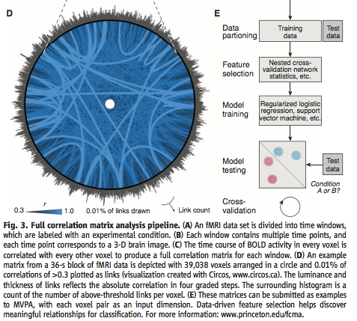
4. Does module calculation change? Or does it update based on thresholding/selected subjects? - yes, it can be changed / updated, but doesn’t update automatically.
5. Which ROI each dot is in the 3d Graph view
6. Dashed vs. dotted lines — need a legend on the screen  
   - See comments under 8 below… shape would be in the legend, and you wouldn’t need a legend for the lines.
7. The MDS plot is pretty busy  
   - That’s why you can zoom in & out.
8. Need labels Day 1 and Day 2  
   - Could just use Shape to denote Scan Session (we have 4 sessions). As long as you could select any combinations of session, you could look at effects of Day1 vs Day2 or Pre vs. Post, etc.  
   - Also, I think it’s rare that anyone would need to examine whether including or excluding the averages makes such a difference, so maybe a feature that is so easy to see (shape) shouldn’t be wasted on average vs. individual.
9. When you click the triangles for Day 1 and Day 2 average, the file that it says it is doesn’t seem to be correct  
   - Is this so? Hmmm?
10. Instead of functional connectivity, trial-by-trial correlation matrix where you can only see trials with feature X
11. Extracting figures from the glass brain (to save out)  
    - this would be really useful for publishing data, making slides to present data, etc.
12. Extracting a rotating video of glass brain.  
    - this would be really cool for giving lecture presentations of data